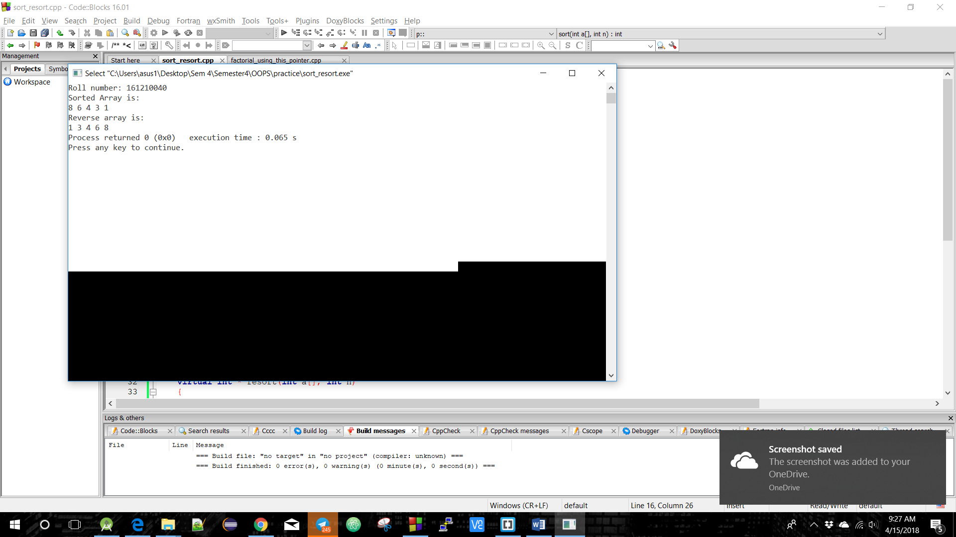

**Sort Resort Using Virtual Function**

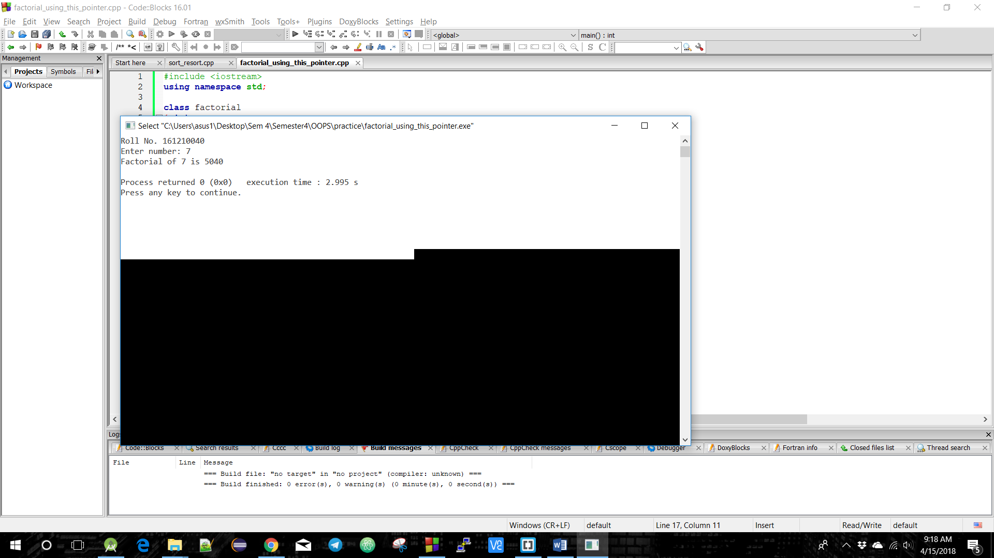

**Factorial Using This Pointer**

**A screenshot of a cell phone

Description generated with high confidence**

**A screenshot of a cell phone

Description generated with very high confidence**